Name: Mriganka Patra

Emp ID: 2415820

Email: [mriganka.patra@cognizant.com](mailto:mriganka.patra@cognizant.com)

Day 8 – Assignment 2

Objective: Understand Sales and Service Cloud features, build reports and dashboards, and configure security settings for data protection.

Tasks:

1. Enable Sales Cloud and configure key features:

* Lead, Opportunity, and Contact Management
* Configure Sales Path or Sales Process

1. Enable Service Cloud and set up and simple Case Management Process:

* Create Case Record Types and assignment rules

1. Build 2 custom reports and combine them into a dashboard:

* Leads by Source
* Case by priority and Status

1. Apply Salesforce Security Settings:

* Field-level security for sensitive fields (Ex: Revenue)
* Objects-level permissions for Service Agents
* Enable Login IP restrictions for added security

Deliverables:

* Screenshots/config steps for Sales & Service Cloud features
* Dashboard visual and reports
* Security configuration documentation

Task 1: Enable Sales Cloud and configure key features:

* Lead, Opportunity, and Contact Management
* Configure Sales Path or Sales Process

Sales Process :

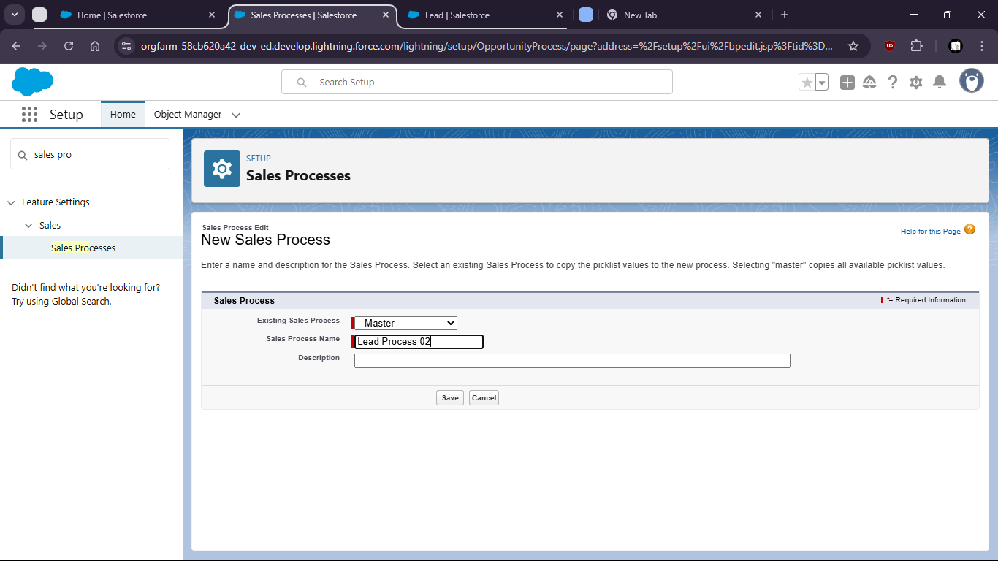

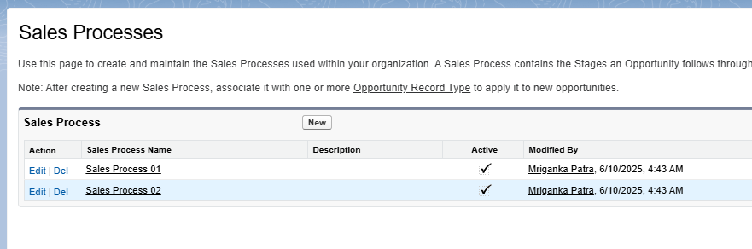

Lead Process:

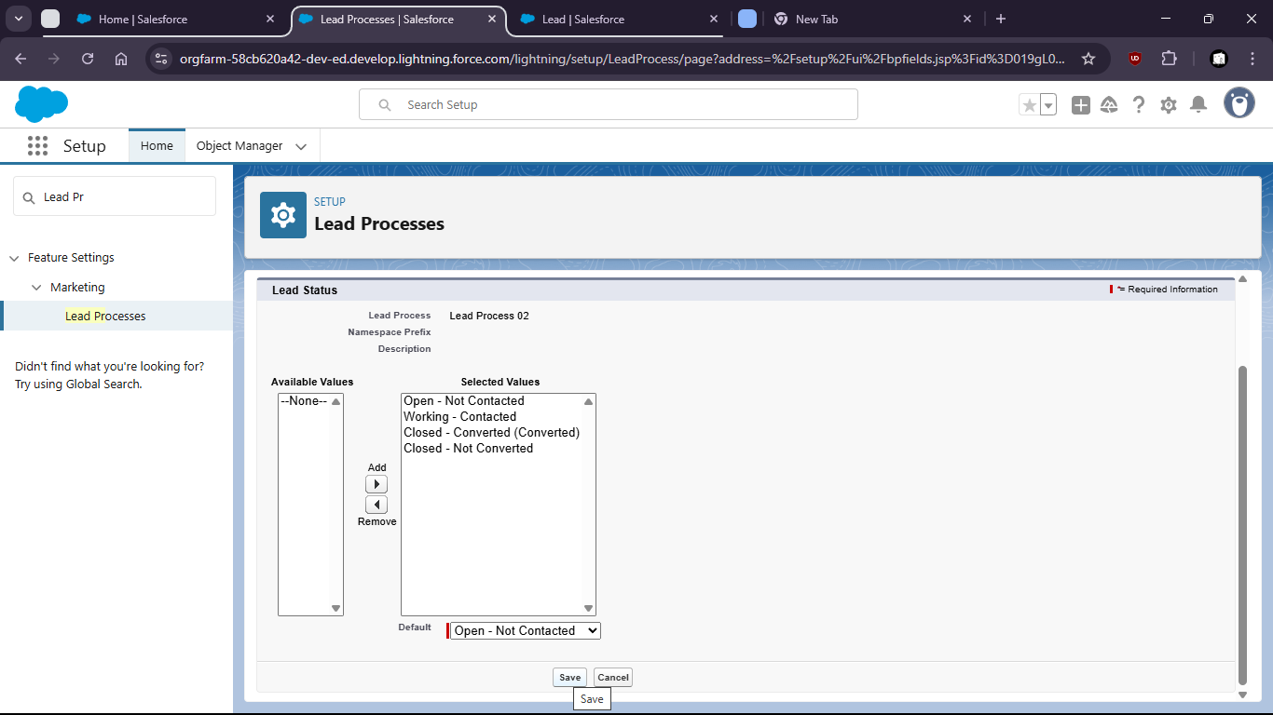

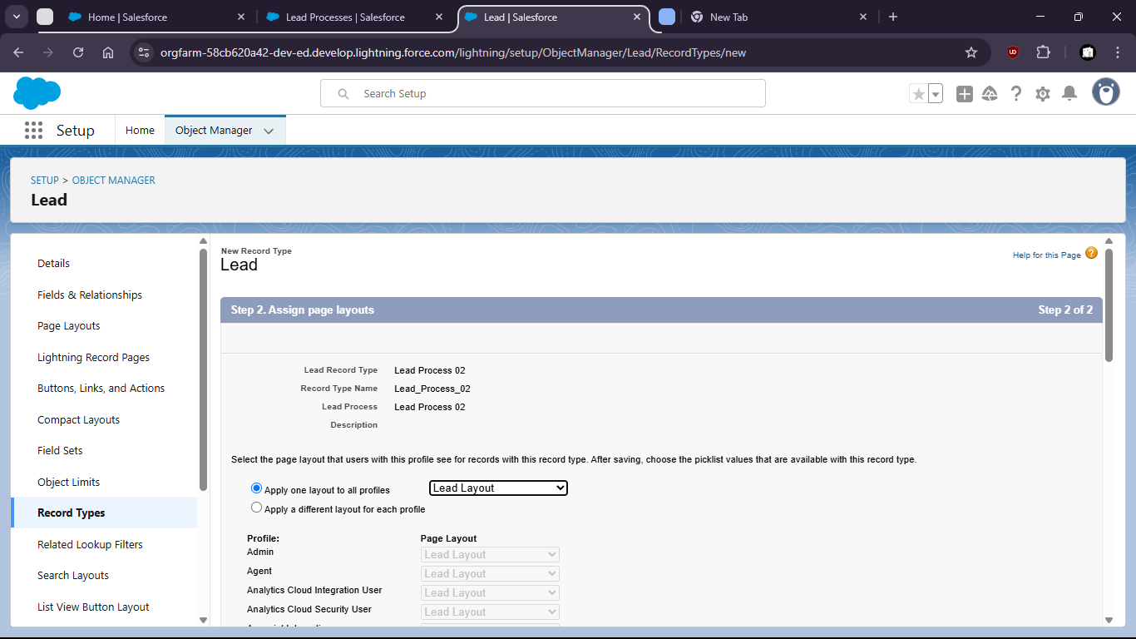

Oppurtunity:

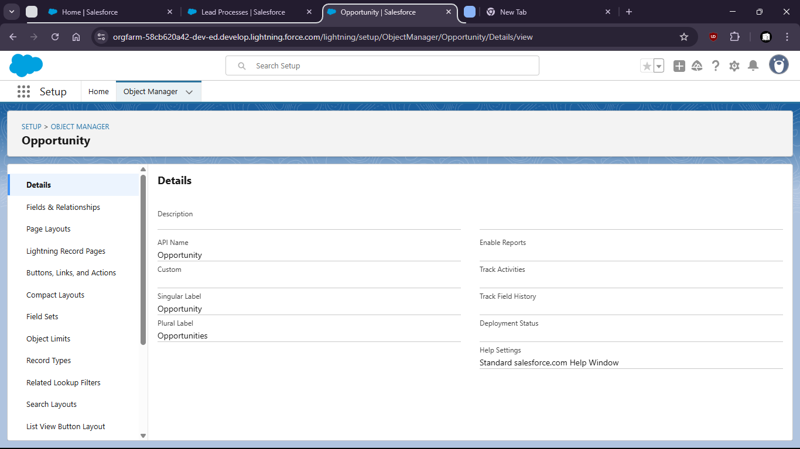

Contact:

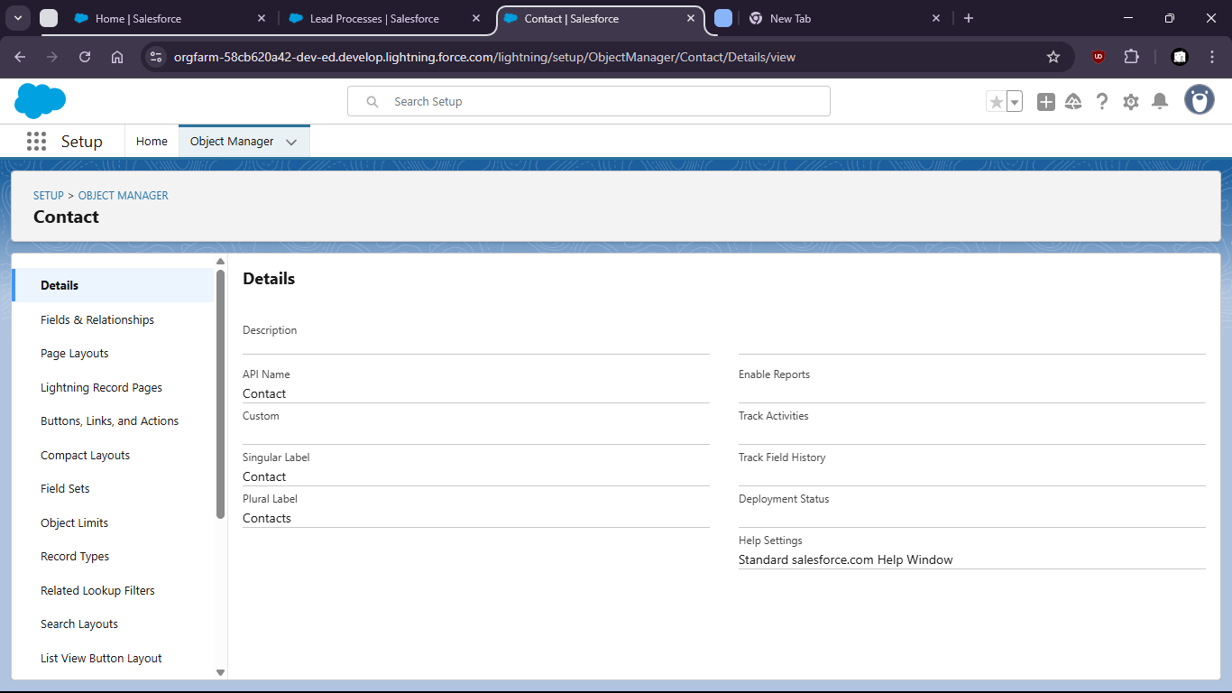

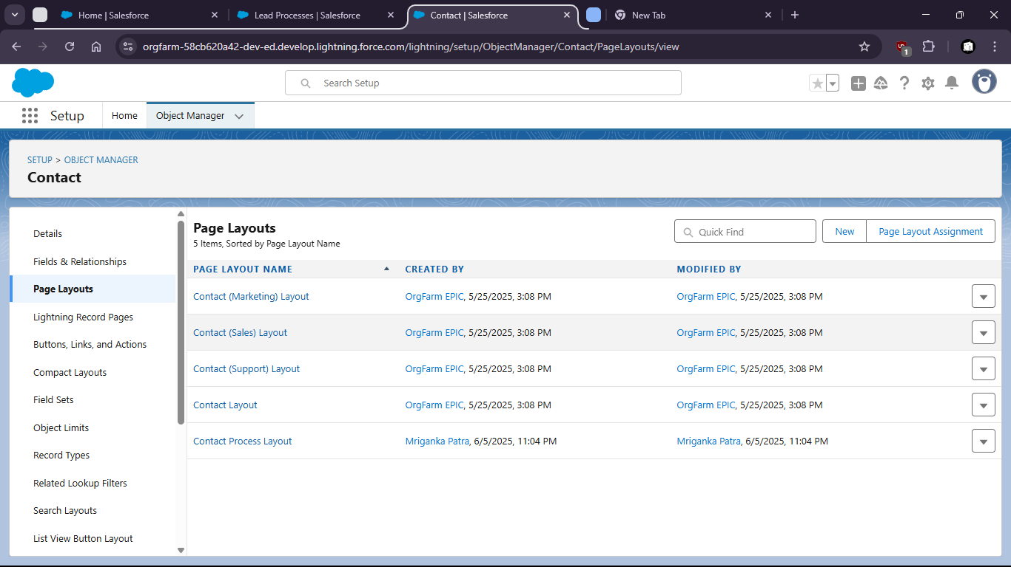

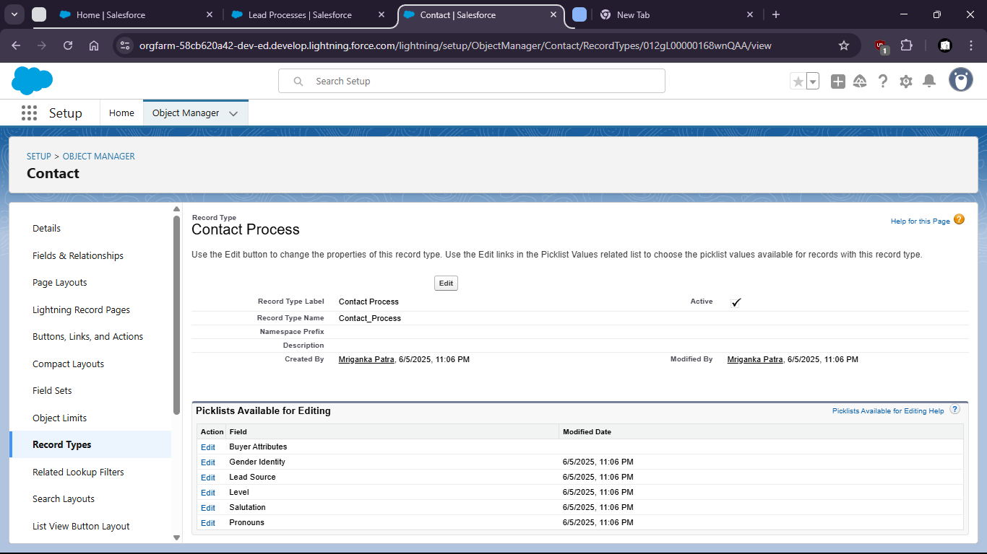

Task 2: Enable Service Cloud and set up and simple Case Management Process:

* Create Case Record Types and assignment rules

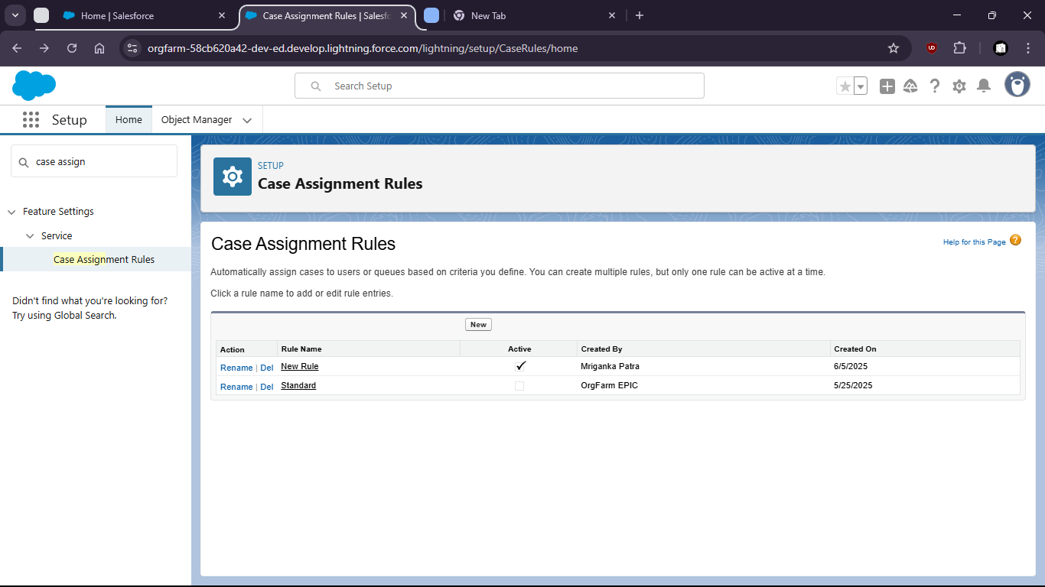

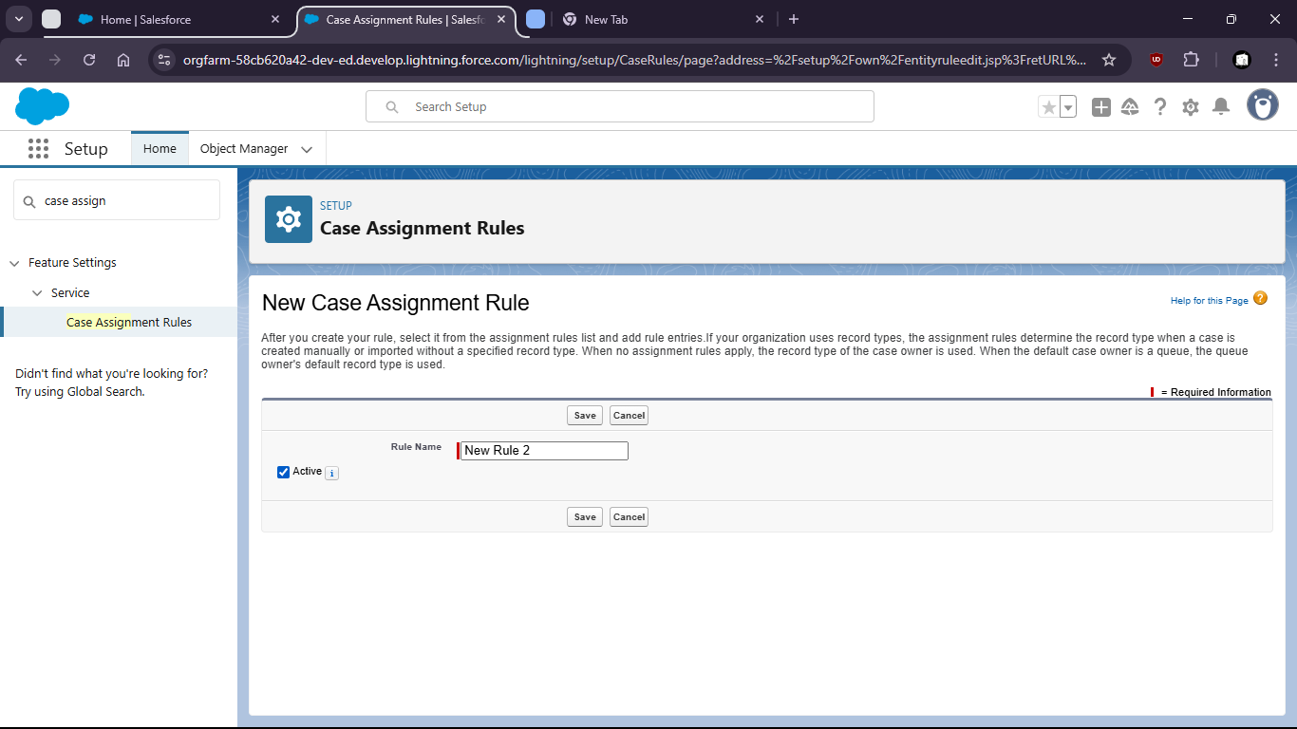

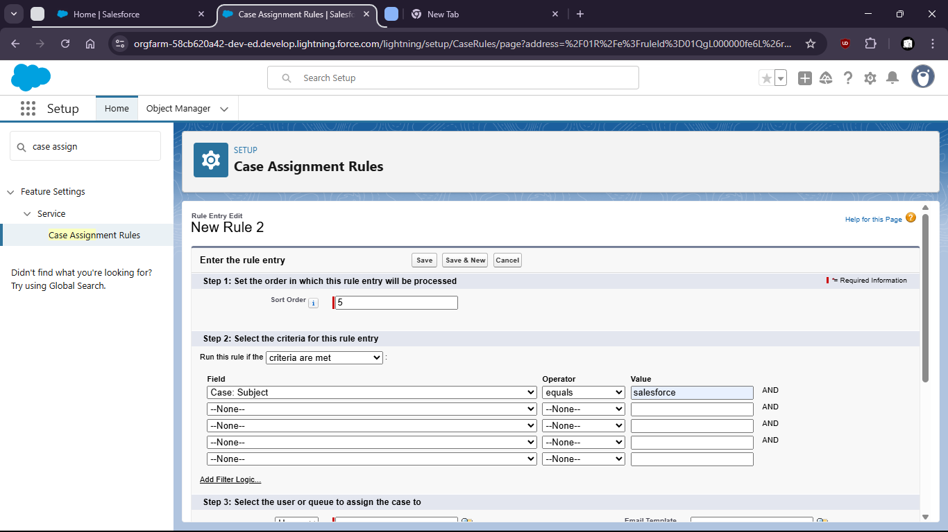

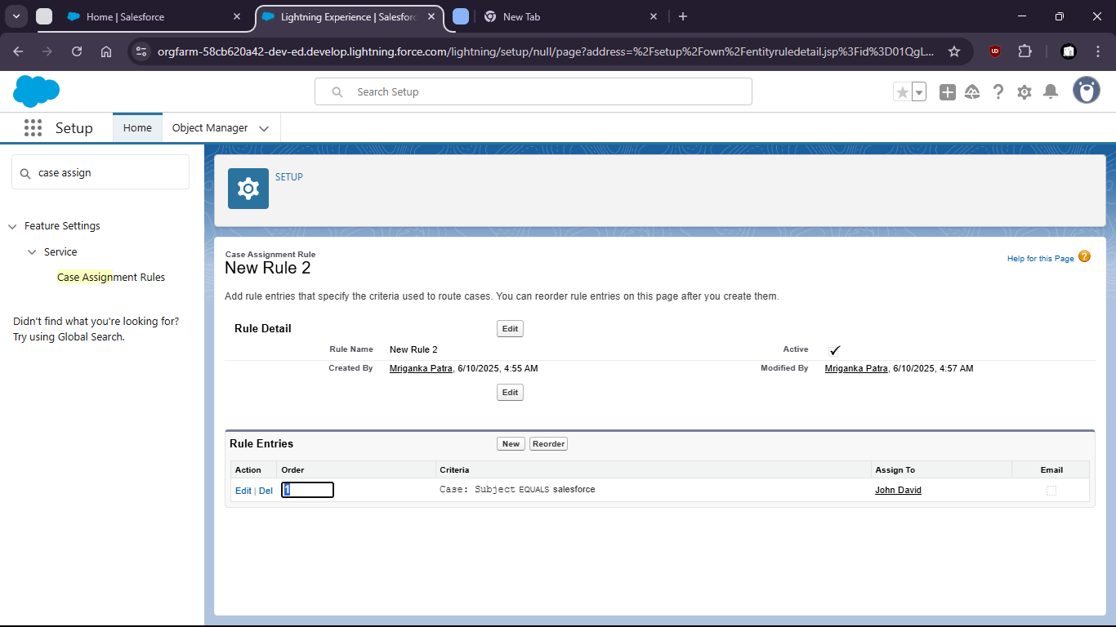

Task 3: Build 2 custom reports and combine them into a dashboard:

* Leads by Source
* Case by priority and Status

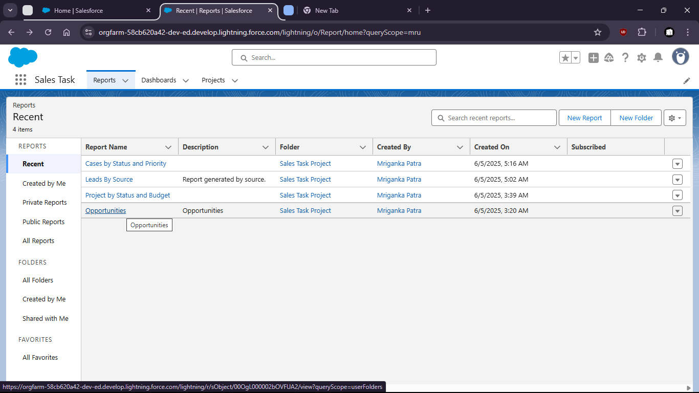

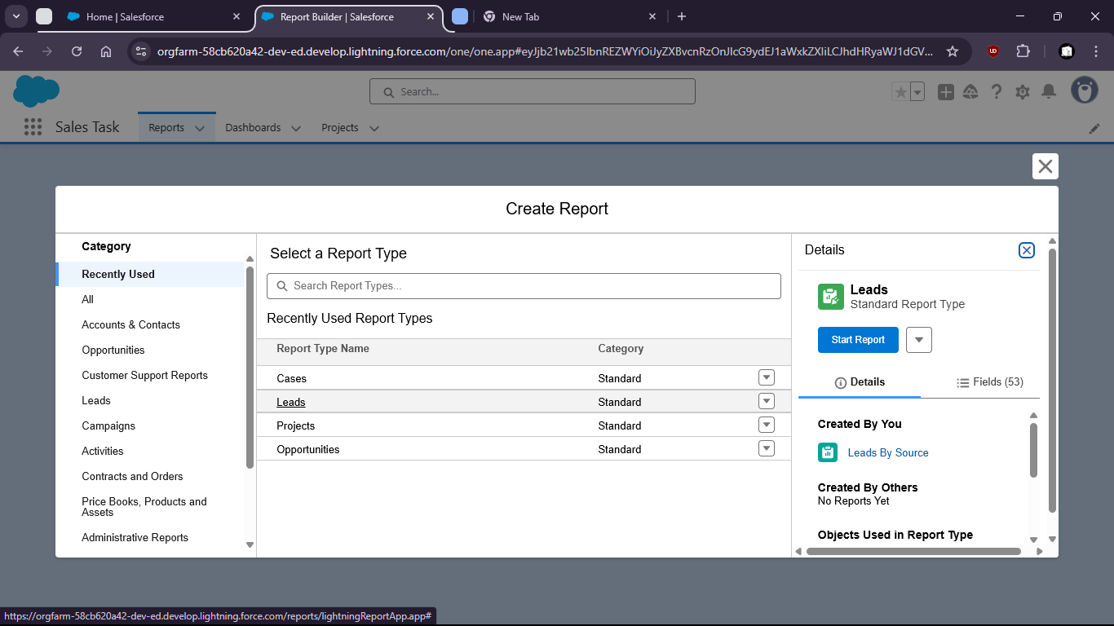

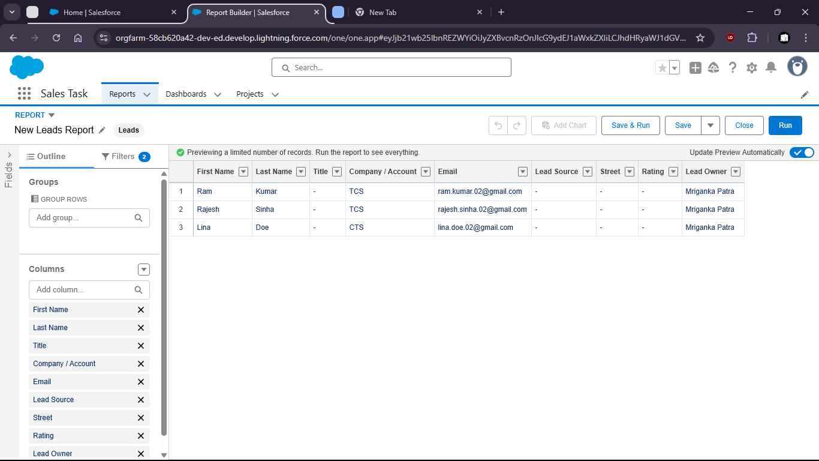

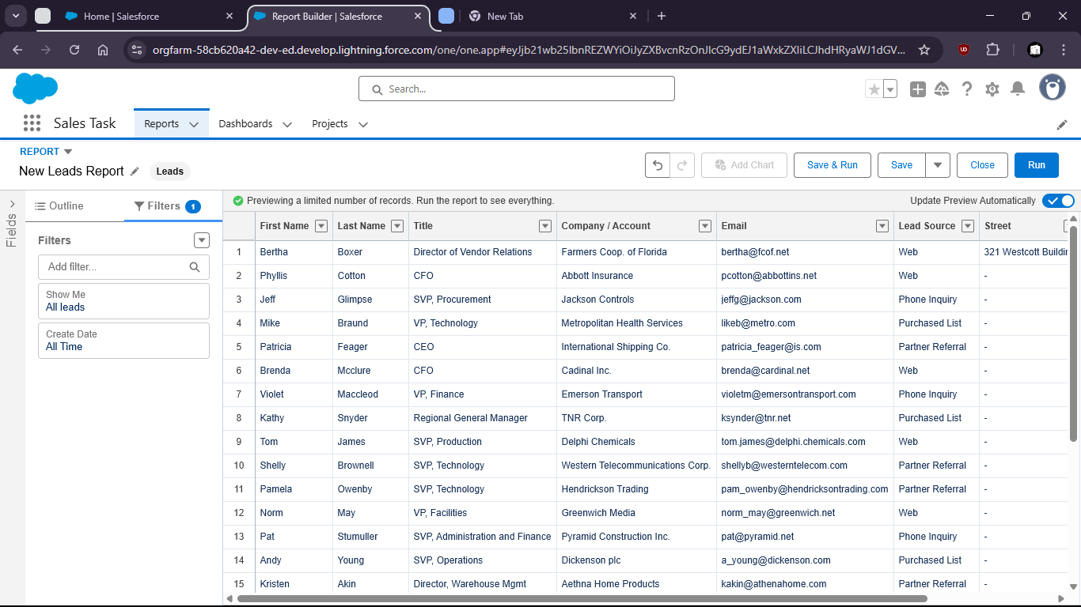

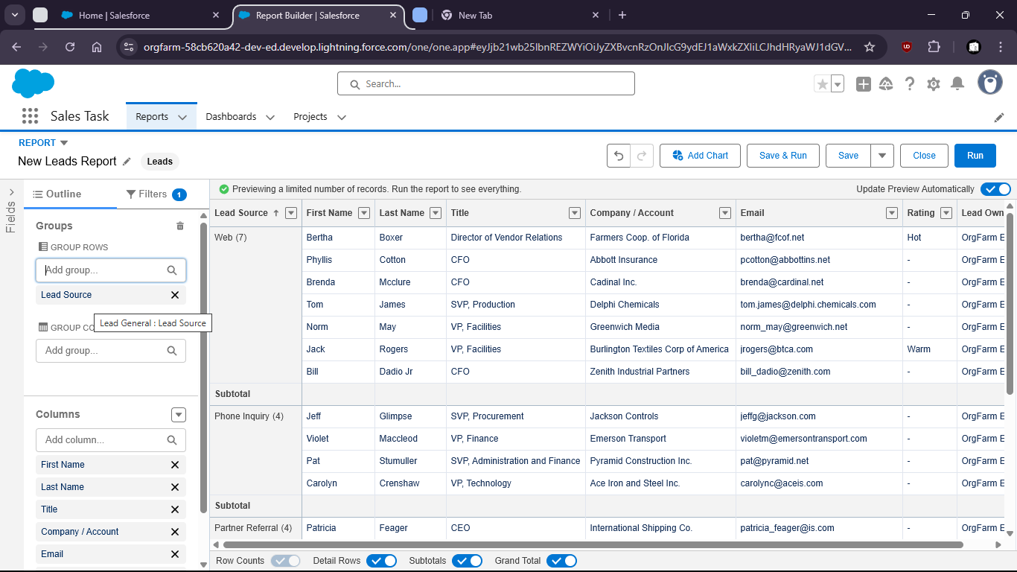

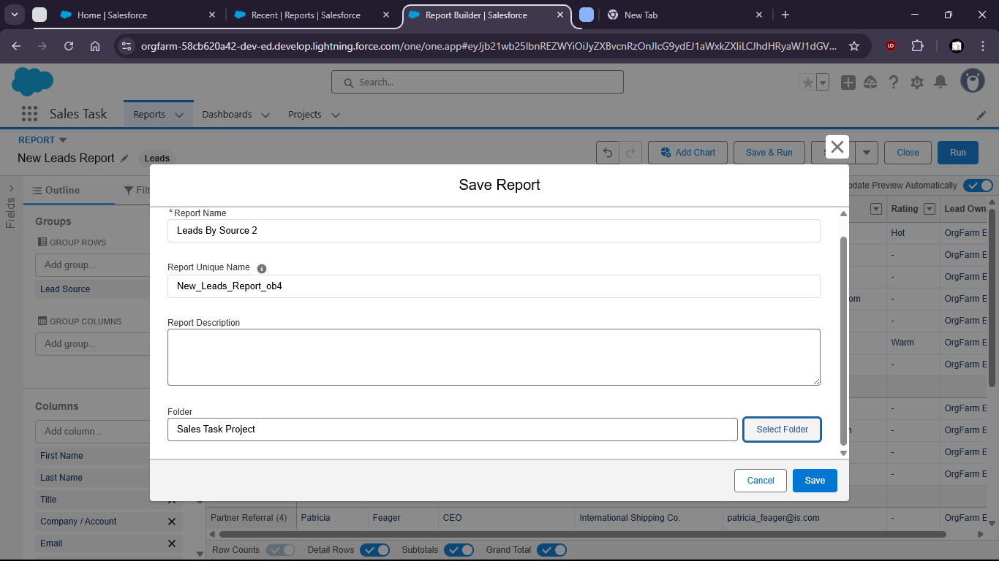

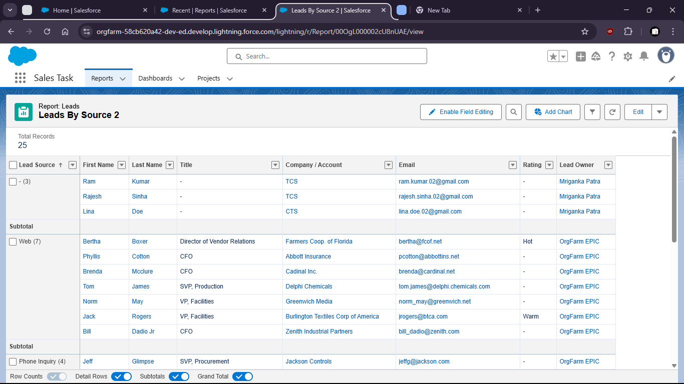

Cases By Priority and Status:

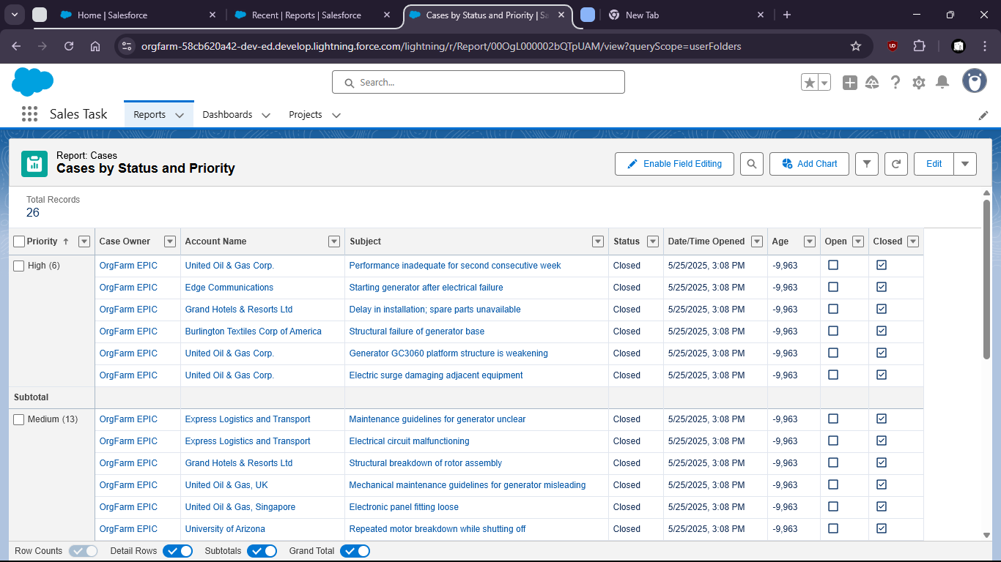

Dashboard View:

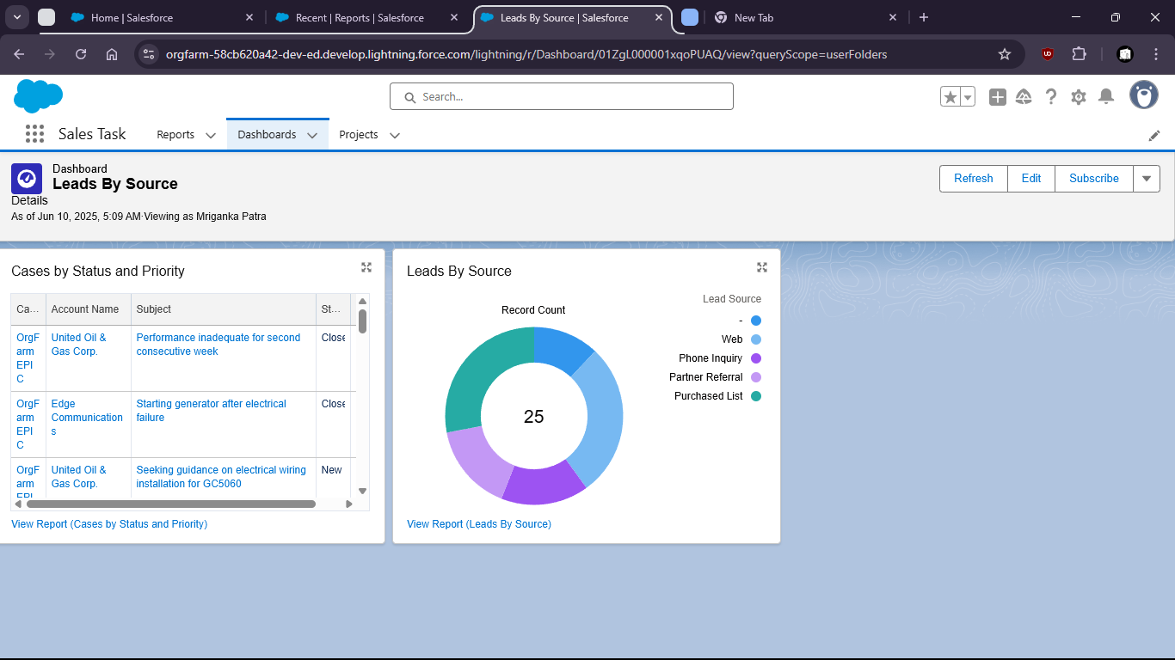

Task 4: Apply Salesforce Security Settings:

* Field-level security for sensitive fields (Ex: Revenue)

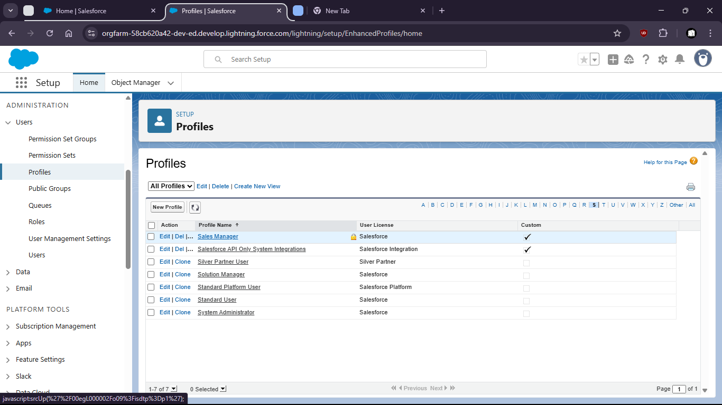

Field Level Security

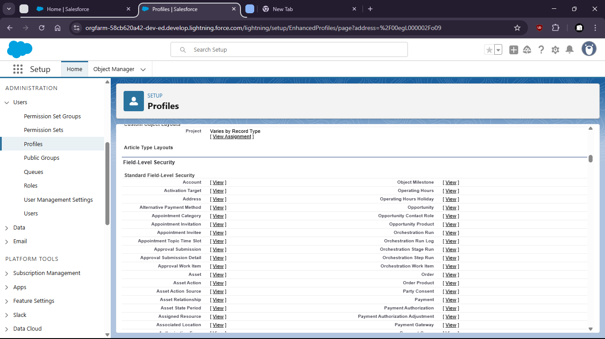

Under Account: Annual Revenue

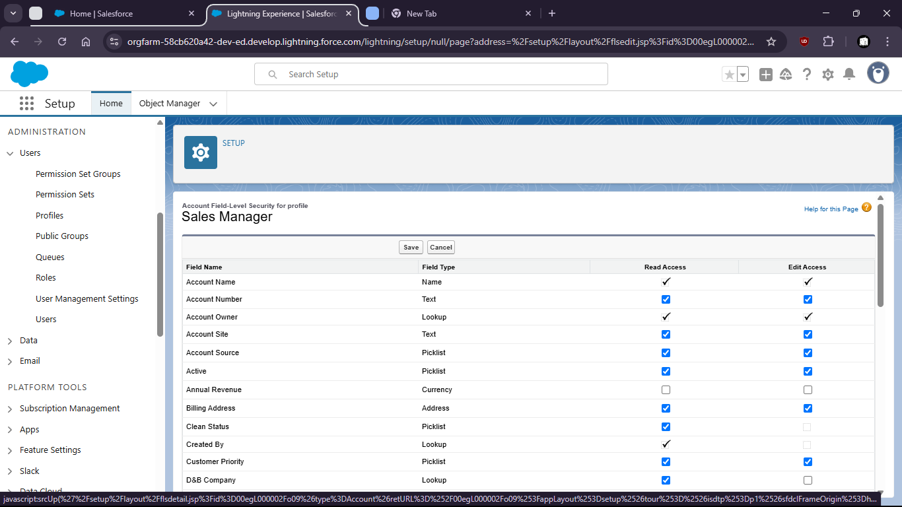

* Objects-level permissions for Service Agents

Standard object permissions

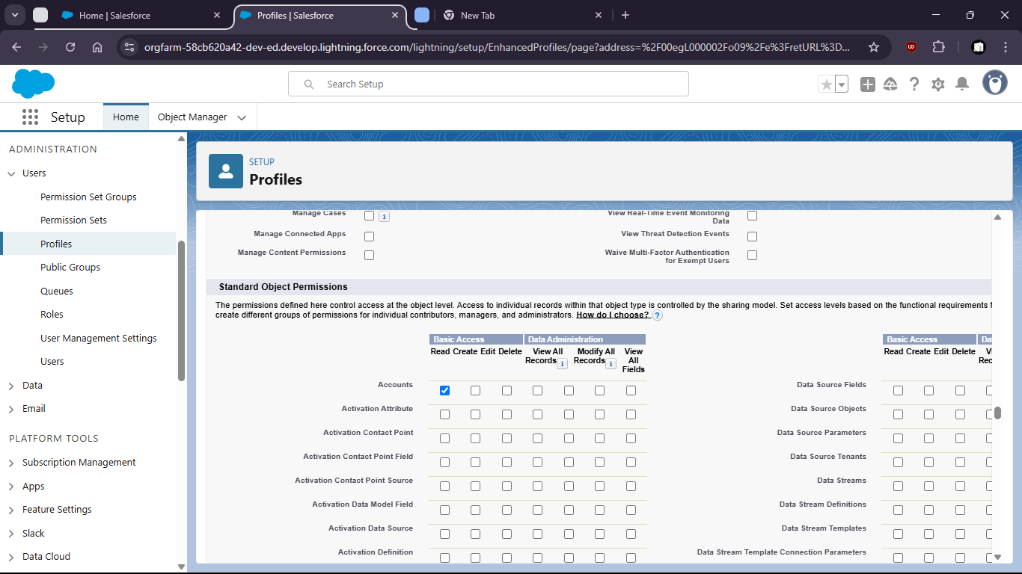

* Enable Login IP restrictions for added security

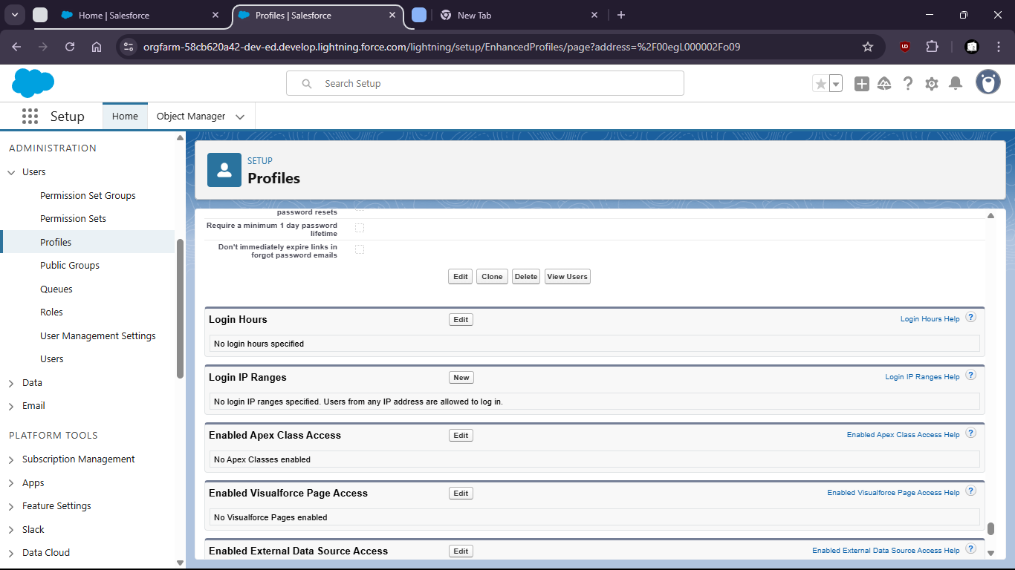

To get the ip:

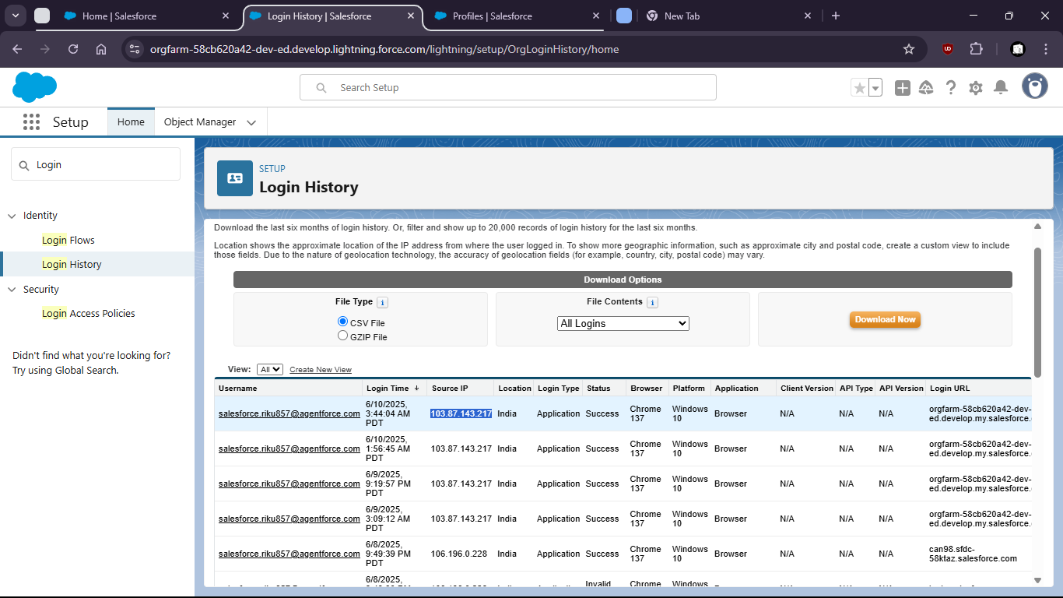

now set the ip:

